Chapter 14, Solution 71.

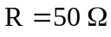, 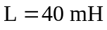, 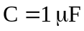

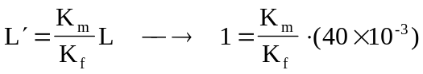

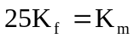 (1)

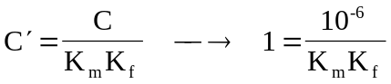

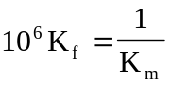 (2)

Substituting (1) into (2),
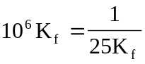

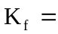2x10^{–4}

